**The Sleep Sensei Story**

I have trouble falling asleep at night. I used to take over-the-counter remedies, and I've tried prescription stuff, but these either made me feel groggy the next day or had side effects that were not worth the benefits. I then stumbled upon some smartphone apps and devices that use a rising and falling pattern of light to help you get to sleep by training your breathing. I tried these with some success, but I found that they all had one major flaw: they required your eyes to be open. Who in the world tries to fall asleep with their eyes open?!

Using my arduino skills, I set to create a device that will help coach my breathing to ease myself to sleep with my eyes closed. Thus the Sleep Sensei was born, with its pivoting base and 4 ultra-bright red LEDs that can shine through eyelids, it aims to fix the problems of similar apps and devices.

**The Device Design**

The Sleep Sensei is designed to shine a pattern of light through your eyelids. This pattern of light is used to coach your breathing pattern, which encourages your breaths to get longer as time progresses. To ensure that enough light is delivered, I put 4 LEDs on the device; however, the maximum brightness is adjustable to account for different tastes. In order to account for different heights of nightstands, I made the device able to pivot to encompass a wide range of scenarios. For those that sleep with a partner, I added side-shields to better concentrate the light to reduce any stray light that may annoy others.

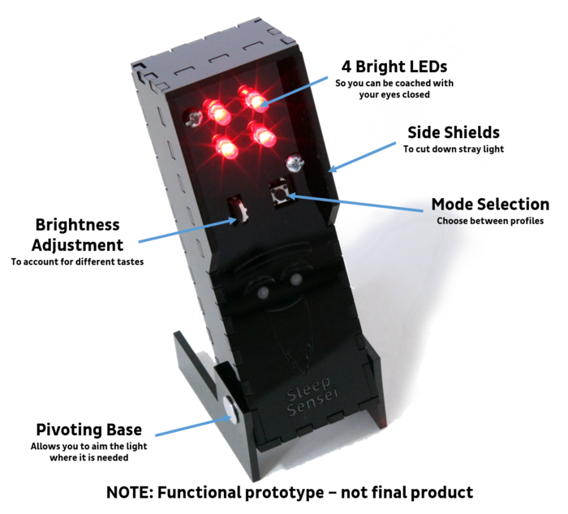

I chose laser cutting to make the kit easy to ship and mass produce. With the goal order volume (around 1000 units), laser cutting proved to be an affordable way to make a custom design.

The circuit board was designed with fritzing, and the logic and programming were done with arduino, which are both open source tools.

All aspects of the design (arduino code, circuit board designs, mechanical design files, website assets, photos, and documentation) are open source and are available on my [github page](https://github.com/jerwil/SleepCoach" \t "_blank). I will continue to refine the design and produce more prototypes using the Kickstarter funding, and during the development time, I encourage advanced users to fork the repository and provide me with suggestions and ideas to include in the final product!

**How it Works**

The Sleep Sensei works by reducing your breathing rate, causing increased relaxation and bringing your breathing pattern closer to the reduced breathing pace that comes with sleep. It also has the benefit of giving you something to focus on for an extended period of time, which can be helpful for those with sleep troubles due to active minds.

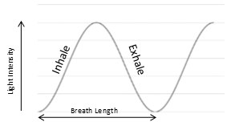

Using calming red light, the Sleep Sensei produces a sine wave pattern of light that you follow with your breathing. As the light begins to brighten, the user inhales, and as the light dims, the user exhales. As time passes, the breath length increases up to the maximum length specified by the user’s settings. It is a very gradual and unnoticeable change that happens progressively over time.

**Who it's for**

The Sleep Sensei is for people who have trouble falling asleep. The Sleep Sensei primarily helps those with sleeping problems caused by stress or an overactive mind at bedtime. The current design of the Sleep Sensei is primarily designed for users that can lay on their side to fall asleep; however, if you must fall asleep on your back for medical or other reasons, you can still use the Sleep Sensei on an elevated surface to point down towards your eyes.

**Features**

*Bright and Directable Light*

The main innovation of the Sleep Sensei is that it uses bright light capable of being seen through the eyelids in order to make it visible with eyes closed. Other similar products are just not bright enough to achieve this and require open eyes.

The Sleep Sensei has a pivoting base to allow you to shine the coaching light directly at the eyelids no matter how tall, short, or non-existent your nightstand is.

*Adjustable Brightness*

The maximum brightness of the Sleep Sensei can be adjusted any time using the adjustment wheel. This allows you to shine it on a wall for eyes-open coaching, dim it a bit if you are sensitive to light, or stare right at it for a meditation session.

*Customizable Breathing Pattern*

Another unique innovation of the Sleep Sensei is the user's ability to program custom breath lengths to suit their tastes and breathing rates. The user can choose initial and final breaths ranging from 4 seconds to 20 seconds long. Defaults are still available as a starting point.

*Simple Design*

When I set out to make this project, I was determined to make the final design as simple as possible, both to reduce cost and to make using it simple and easy.

**Feedback and the Sleep Study**

When I first created the Sleep Sensei, I used it on myself for several weeks with a general feeling that it was helping me fall asleep faster. I wanted to quantify this somehow, so I began tracking my sleep using a sleep tracking app on my smartphone. After seeing a significant positive trend in the amount of time it took me to fall asleep using the Sleep Sensei, I decided that I wanted data from more users to see if the device worked for others. Thus I started the Sleep Study.

The hypothesis was simple: “The Sleep Sensei will reduce users’ average time to fall asleep.” I made posts on reddit’s /r/insomnia, /r/arduino, and /r/quantifiedself subreddits to get volunteers for the study using [this advertisement](https://raw.githubusercontent.com/jerwil/SleepCoach/master/Media/Advertisement%20One%20Page.jpg)  (The device used to be called the Sleep Coach). Of the 5 volunteers I was able to get, all of them showed some improvement in the time it took them to fall asleep. The full report can be [found here](https://github.com/jerwil/SleepCoach/raw/master/Documentation/Data%20Summary%20-%20Round%202.pdf), and the raw data from the study can be [found here](https://github.com/jerwil/SleepCoach/raw/master/Documentation/Complete%20Data%20Users%201-5.xlsx).

**Some comments from the study participants:**

“*I think the quality of sleep has been improving, and I think that’s the Sleep Sensei. When I start having issues again I pull it out and it does help*” – Alice S, TX

“*I was really impressed with the Sleep Sensei- it cut the amount of time it took me to fall asleep by about half … based on the survey, I basically don’t have insomnia anymore and it feels that way*” Marijke S, MA

“*The Sleep Sensei allows me to fall asleep in at least under 30 minutes, sometimes even as few as 7 minutes, which is great for me! I would definitely recommend this device to anyone who is on the search for something new to help them fall asleep, someone who perhaps has tried every other sleep aid without finding anything that truly helps yet. The Sleep Sensei is awesome!*” – Kate B, GA

“*I’ve noticed a HUGE decrease in how long it takes me to fall asleep which has been wonderful! I really like the machine. It’s easy to use and works well.*” – Kelly P, LA

Now I want to reach a much wider audience with the Sleep Sensei by launching this Kickstarter. Hopefully it will help others as much as it helped the study participants!

**Choosing the Kickstarter Goal**

When I first started producing Sleep Senseis for the sleep study, I created a simple design that I could make cheaply with parts from my local hardware store. Each one was made by hand, a process that took about 90 minutes per Sleep Sensei (more if I had to troubleshoot a problem with my low-quality homemade circuit boards).

After receiving such positive feedback from the sleep study, I wanted to bring the Sleep Sensei to the masses, but I knew I couldn’t keep spending hours just to produce a dozen devices. Thus I have turned to outsourcing the circuit board manufacture and assembly as well as making the mechanical components by laser cutting. I got multiple quotes and found that I need to have at least 1000 Sleep Senseis produced in order to make them economically viable. For example, a batch of 100 circuit boards costs more than 4 times more per board than a batch of 1000 boards!

**The Timeline**

Assuming the Kickstarter is fully funded, this is the plan to make Sleep Sensei a reality:

https://s3.amazonaws.com/ksr/assets/002/729/870/ae031367789bf3bce255e0e27ac0a376_large.png?1413160816

**Progress**

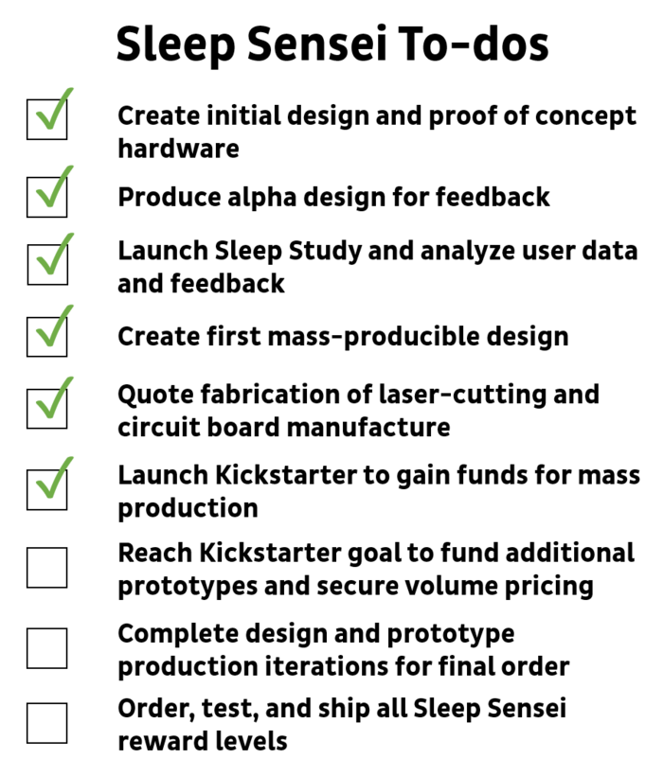

**Rewards Photos and Details**

**Note:** the Sleep Sensei is still under development, so the below images will differ from the final product.

**The bare board:**

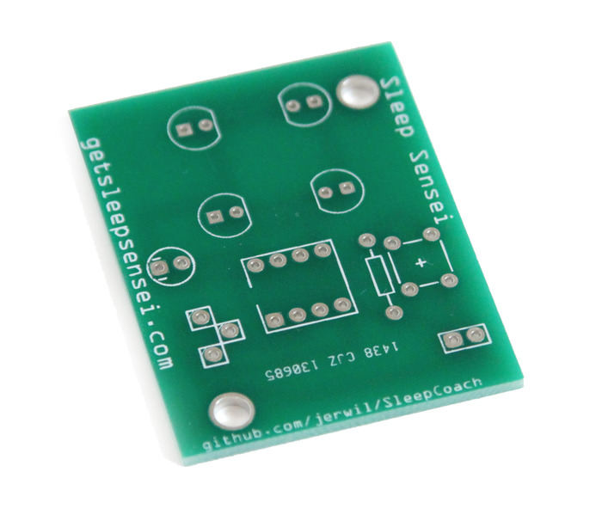

Just the board. Provide your own electrical components and soldering skills to complete the board, or just hang it on your keychain as a token of appreciation for helping this project become a reality.

**The Sleep Sensei Kit:**

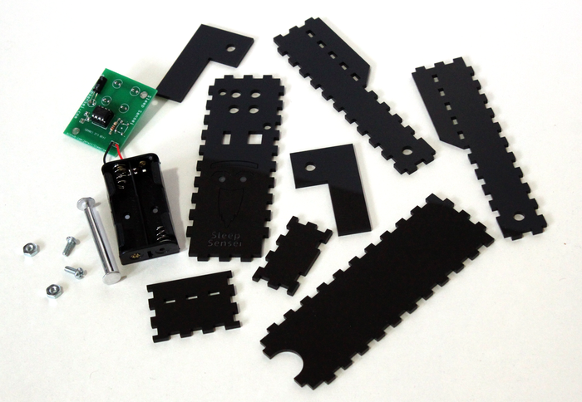

Includes laser-cut parts, assembled electronics board, battery pack (2 AA batteries not included), hinge hardware, and all other needed hardware (TBD). It should take less than 5 minutes to assemble.

**The Assembled Sleep Sensei:**

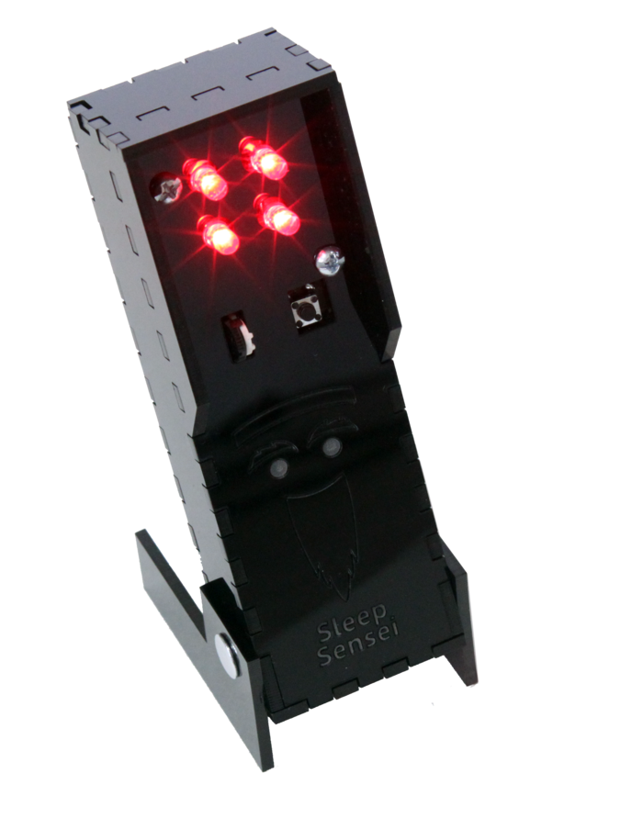

The fully assembled Sleep Sensei put together and fastened together by yours truly.

[Logo designed by RMRDesign](https://www.fiverr.com/rmrdesign)